Green Society Public School
D-21
Ratnanagar-7, Sauraha, Chitwan
Third Terminal Examination-2082
Class: UKG Time: - 2 hrs. F.M.: 50
Sub: English
Name: Roll No.: Sec.:
________________ ______________ OBT.MARKS:
INVIGILATOR EXAMINER
- See the picture and tick the correct sentence. (3)
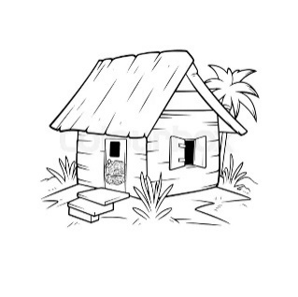 | A nut is in the hut.  A nut is on the hut.
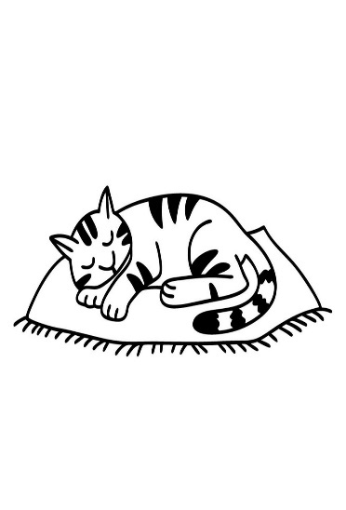 | A cat is on the mat.  A mat is in the cat.
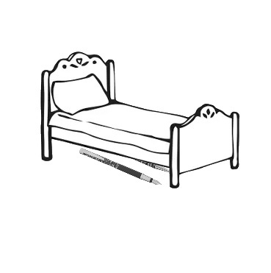 | A pen is under the bed.  A pen is in the bed.

- Change singular into plural. (5)

baby = _____________________
cat = _____________________
book = _____________________
potato = _____________________
copy = _____________________

- Write opposite word. (5)

Up = _____________________
In = _____________________
Good = _____________________
Girl = _____________________
Happy = _____________________

- Add 'ing'. (5)
Drive = _____________________
Run = _____________________
Sing = _____________________
Write = ____________________
Go = _____________________
- Put 'A' or 'an' before the word. (5)
___________bench ___________iron
___________pen ___________fan
___________ox
- Mach the sentences with the correct picture. (5)
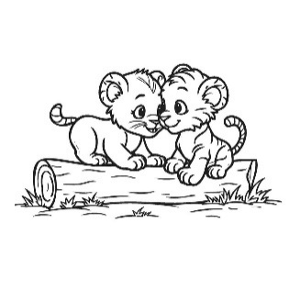 |  | Those are gems
 |  | Those are cubs.
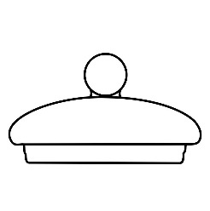 |  | That is mop.
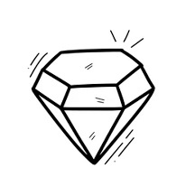 |  | Those are lids.
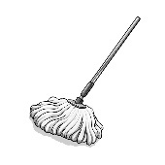 |  | That is tab.
- Fill in the blanks with 'is' 'am', 'are' (5)
- I___________a student.
- She ___________a horse
- They ___________farmers.
- We___________friends.
- It ___________a dog.
- Answer the question in 'Yes, it is', or 'No it is not.' (5)
- Is that a hat?
______________________________________________________________
- Is this a bug?
______________________________________________________________
- Is this a man?
______________________________________________________________

- Is this a book?
______________________________________________________________
- is this a kid?
______________________________________________________________
- Make sentences using He/She/It. (6)
walking | sleeping | eating | jumping | playing | writing

- Complete the paragraph. (6)
My name is……………………………………………….. I am ……..years old. I am a ………………(girl/boy). I study in ………………..My favorite colour is ……………………… I like to eat …………….
The End

